SIX SIGMA THINKING
(A Process to Improve the Process)
SALES FUNNEL EXAMPLE (Two Week Data)
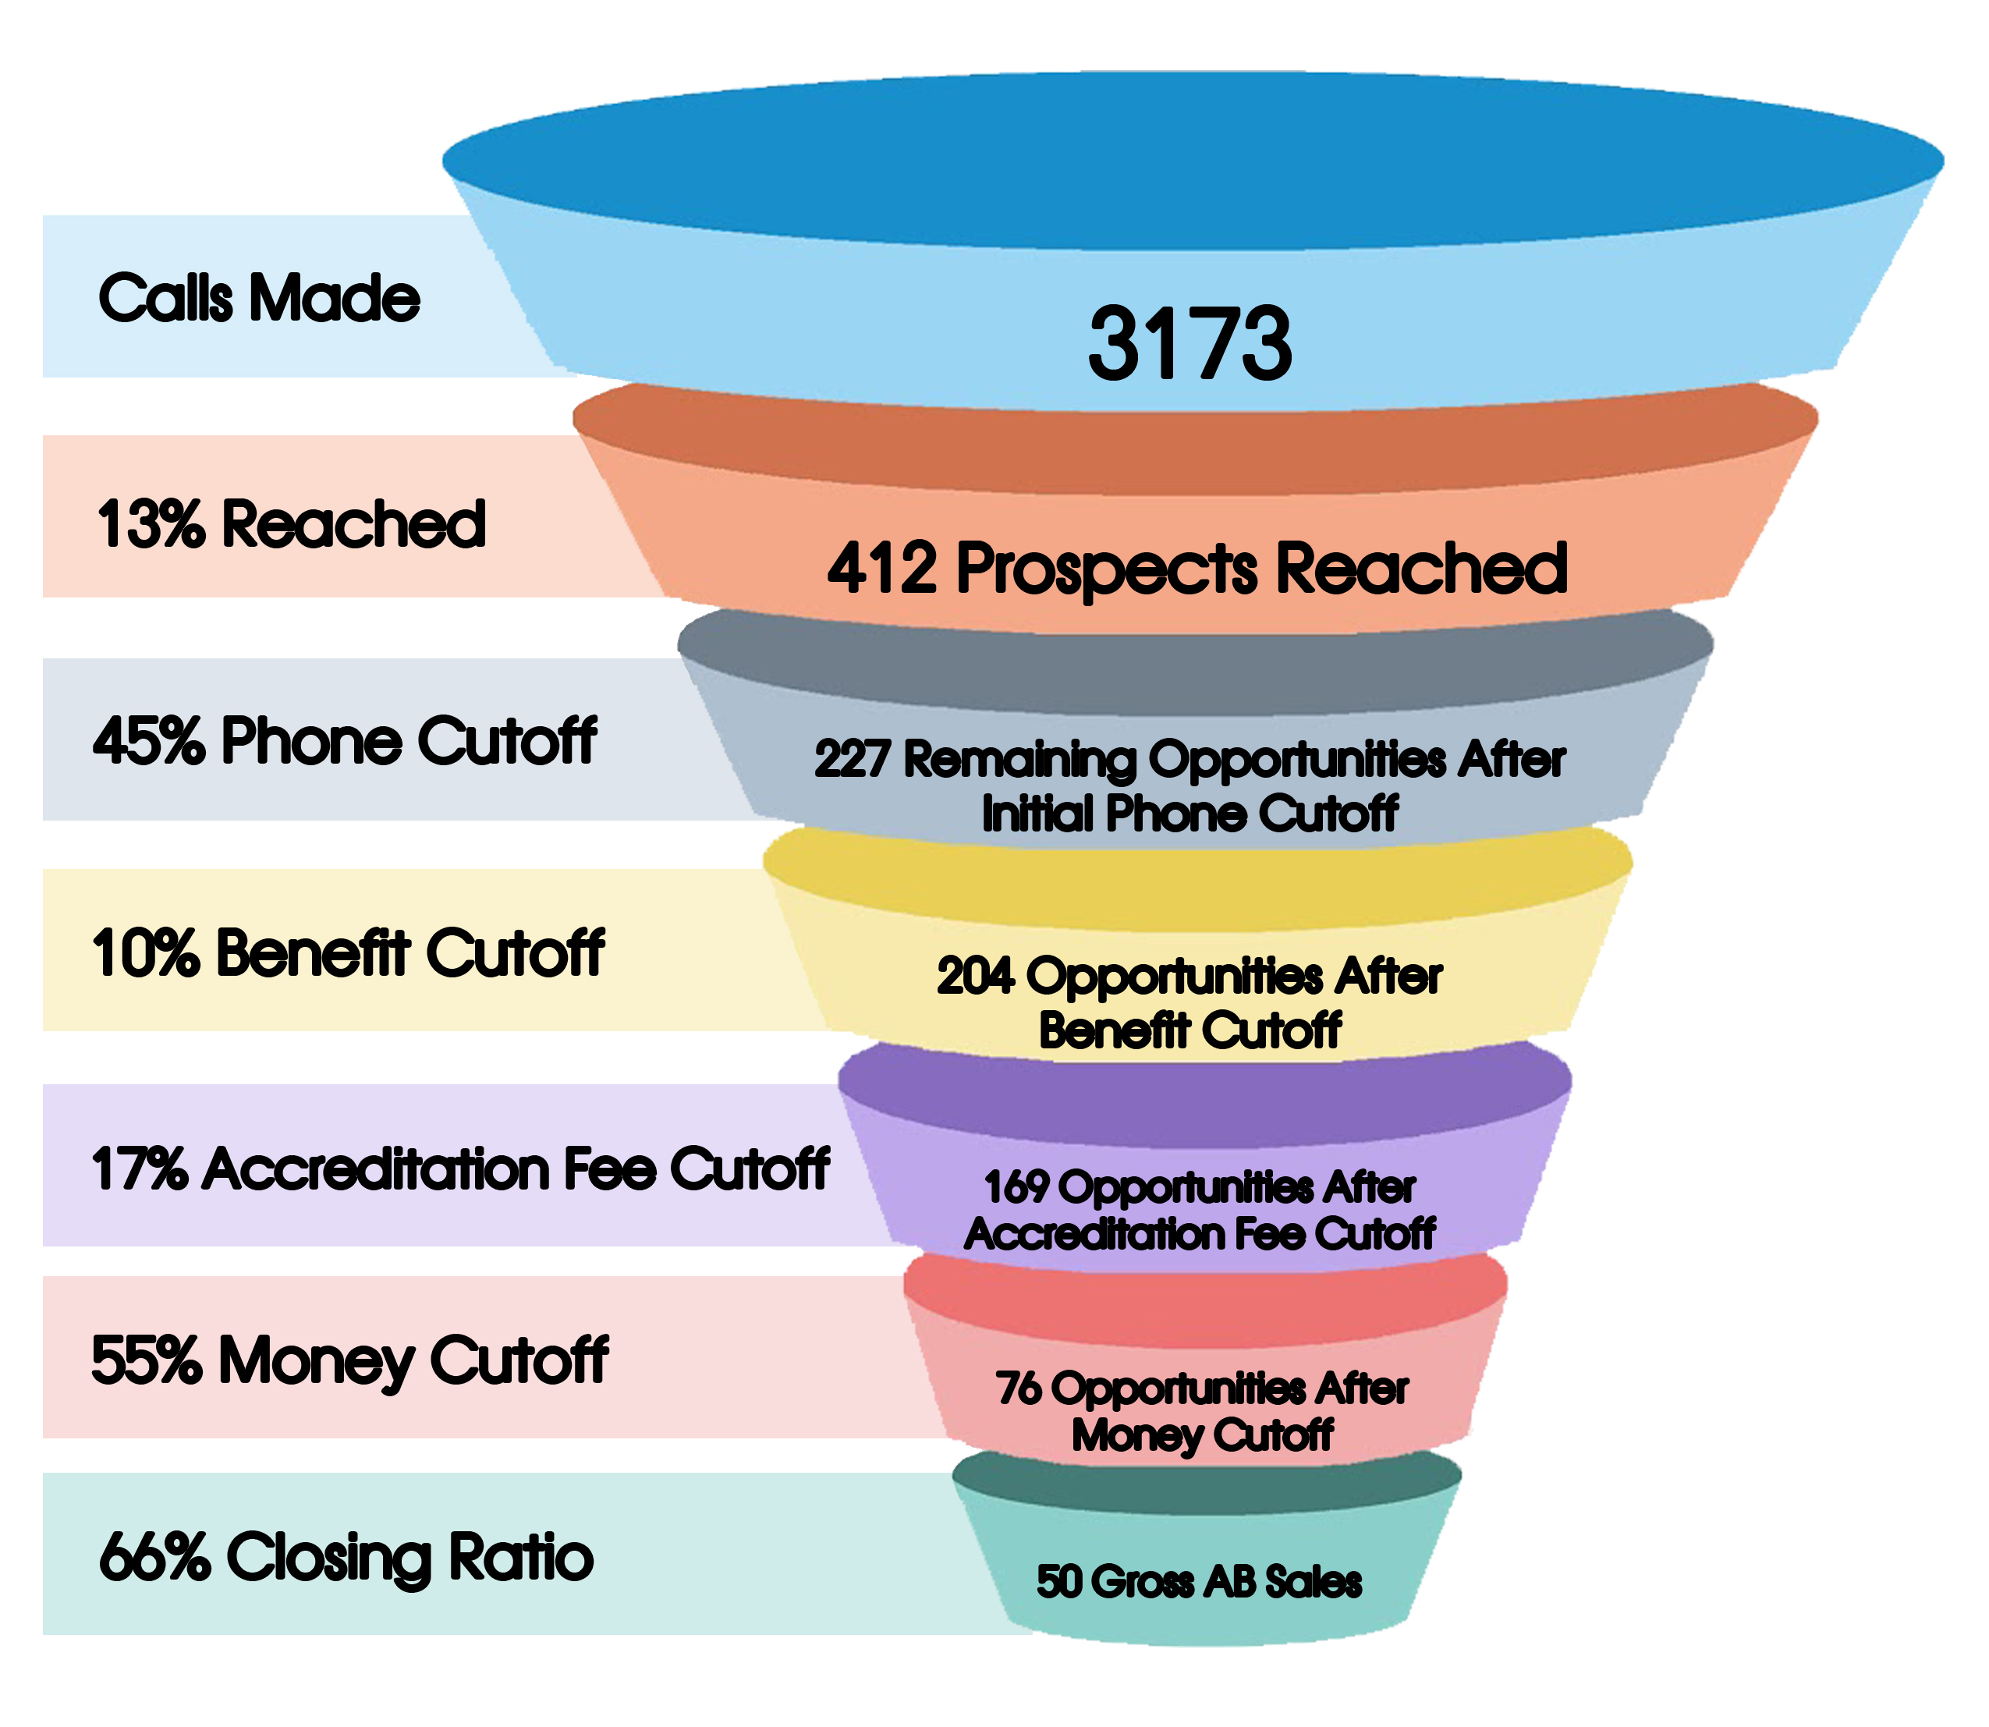
NOTES
This was based on a real situation. In analyzing the funnel, there are two major areas for improvement:
- The 45% phone cutoff – this occurs during the opening statement to the prospect. A potential solution would be to develop a more compelling, benefit-driven, you-focused opening statement. If we reduce the phone cutoffs, we create more sales opportunities in the funnel. Another potential improvement may be in the list we are using to call prospects.
- The 55% money cutoff – This happens when we start asking credit card information and during objections. Improving objection handling may be the answer here or perhaps summarize benefits before asking for credit card information.
The closing ratio of 66% is excellent, but we need to drive more sales opportunities to the bottom of the funnel.
Under the pilot project, we would develop the team funnel (as above) and individual funnels for the sales reps.
This process helps us to “pinpoint” the improvement areas for each rep. Managers can exert the most influence over sales performance during focused, metric-based and specific interactions with their sales reps. Your sales process may be different than above – we will customize it.

